* Customer Account Groups
* Number Range Create
* Number Range Assign to Group
* Customer & Material Master Data
* Create Partner Function
* Create Material Stock
* Create MM for Sales View
* Pre-Sales Activities
* Create Quotations

Customer Account Groups

There are different types of customer account groups that can be created.

|  |  |
| --- | --- |
| **Group** | **Name** |
| X001 | Domestic Customers |
| X002 | Export Customers |
| X003 | One Time Customers |

How to create a Customer Account Group?

Go to SPRO → SAP Reference IMG → Financial Accounting → AR and AP → Customer Accounts → Master Data → Preparations for creating customer master data → Define Account Groups with screen layout (Customers) → Execute

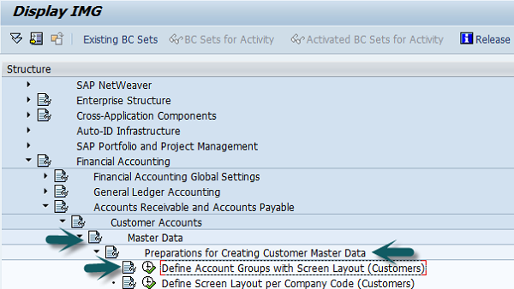

A new window will open → click New entries.

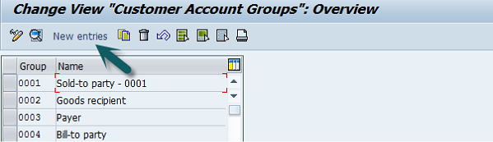

Then again a new window will open. Enter the following details in it.

* **Customer Account Group** − Enter a 4-digit account group.
* **Name** − Enter a name under the General data field.
* **Field Status** − Click on the Company code data.

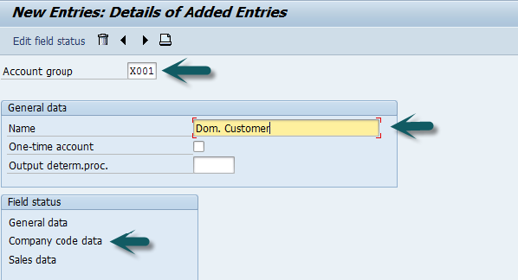

Once you select the field status, a new window will open. Then, select Account Management from the selected group and the click Reconciliation account ‘Req. Entry’

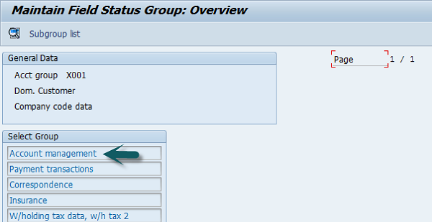

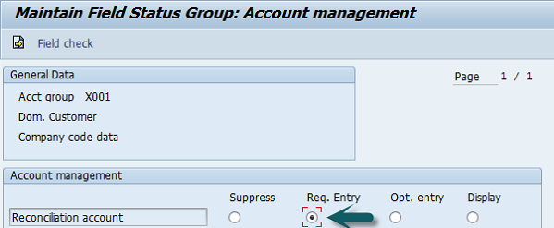

Once this is done, click **Save** to save this configuration. Similarly, you can also create X002, X003 for other customers.

SAP SD - Customer & Material Master Data

Master data is one of the key factors in Sales and Distribution module. There are two levels of masters in SD.

The first level master includes −

* Customer Master
* Material Master
* Pricing Conditions

While, the second level master is −

* Output condition

Create a Customer Master Record

The customer master data contains the information about business transaction and how transactions are recorded and executed by the system. A Master contains the information about the customers that an organization uses to do business with them.

Key tables in Customer Master

|  |  |  |
| --- | --- | --- |
| **Table Name** | **Key** | **Description** |
| KNA1 | KUNNR | General Information |
| KNB1 | KUNNR,BUKRS | Company Code |
| KNVV | VKOGRG,VTWEG,SPART,KUNNR | Sales Area |
| KNBK | KUNNR,BANKS,BANKL,BANKN | Bank Data |
| VCNUM | CCINS,CCNUM | Credit Card |
| VCKUN | CCINS,CCNUM,KUNNR | Credit Card Assignment |
| KNVK | PARNR | Contact Person |
| KNVP | VKORG,VTWEG,SPART,PARVW,KUNNR | Partner Functions |

Main Transaction Codes in a Customer Master

|  |  |
| --- | --- |
| **S.No** | **Transaction Codes & Description** |
| 1 | **XD01, XD02, XD03**  Used to create/change/display customer centrally |
| 2 | **VD01,VD02,VD03**  Used to create/change/display customer sales area |
| 3 | **FD01,FD02,FD03**  Used to create/change/display customer company code |
| 4 | **XD04**  Display change documents |
| 5 | **XD05**  Display change documentsUsed to block Customer − Global, order, delivery, billing, sales area, etc. |
| 6 | **XD06**  Used for deletion |
| 7 | **XD07**  Change Account Group |
| 8 | **VAP1**  Create Contact Person |

Creating a Customer Master Data

To create a customer master data, you need to use an Account group.

T-Code: XD01/VD01/FD01

Note that if you use −

* **XD01** − This Includes sales area in the customer master and data is stored in tables KNA1, KNB1 and KNVV.
* **VD01** − This includes sales area & data, which will be stored in tables KNA1, KNB1 and KNVV and there is no company code data in this.
* **FD01** − This is company code level & data is stored in tables KNA1 and KNB1.

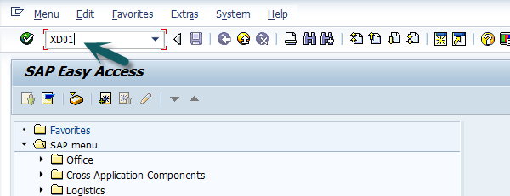

Then a new window will open. Enter the following details −

* Select the Account Group from the list.
* Enter the customer number and select the company code.

Then you can enter the Sales Area details like −

* Sales Organization
* Distribution Channel
* Division

In case you want to take reference from an existing customer to create customer master, you can use the reference option.

Once all the details are selected, click the **Tick** mark.

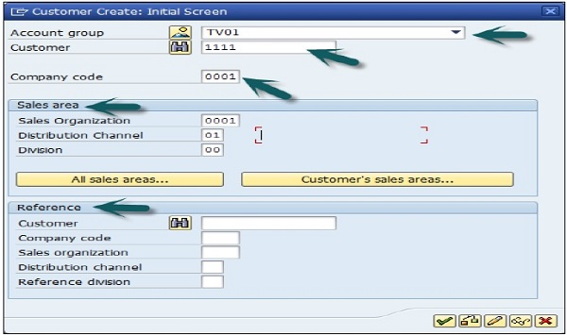

A new window will open to enter the customer master data. This customer master data has 3 key sections −

* General Data like Title, Name, Address, etc.
* Company Code Data and
* Sales Area Data.

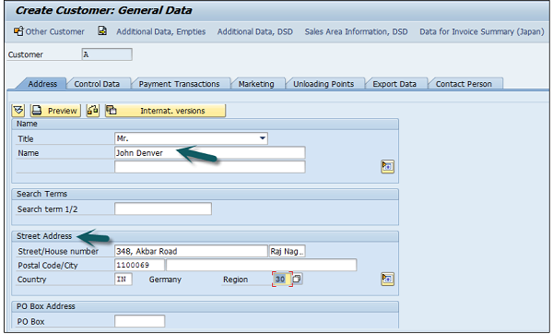

Note that this region fields define the tax calculation like VAT, CST, etc. The next step is to go to Control Data and enter the following details.

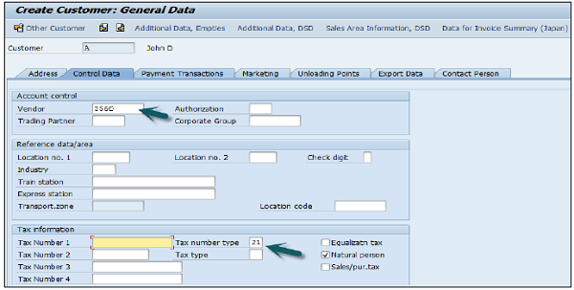

Then you have to enter the particulars in Payment Transaction tab and enter the details of – Bank City, Bank Key, Bank Account and Account Holder Name. You can also add more details by clicking on the Bank data button.

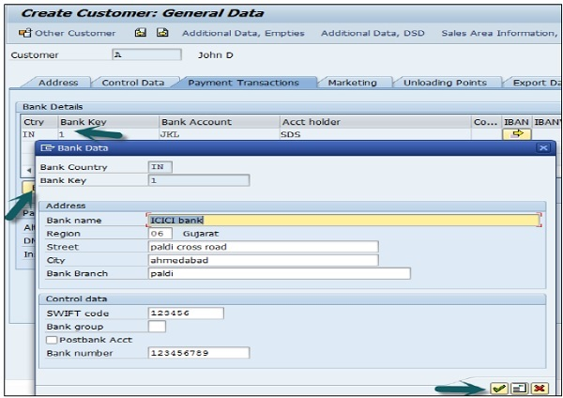

The next step is to go to the Sales Area data and enter the details – Shipping Data, Customer Pricing and Partner Functions, etc.

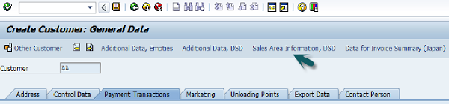

Next is to click on the Save icon at the top and you will get a confirmation that the customer has been created with #.

Saving Icon

If you have to make any further changes to the customer’s master data, you can use **T-Code: XD02.**

SAP SD - Create Partner Function

Partner function allows you to identify which functions a partner has to perform in any business process. Consider a simplest case, where all the customer functions are performed by the partner customer. As these are mandatory functions, they have to be defined as obligatory functions in a SD system.

These functions are categorized as per partner type in Sales and Distribution system. The below partner types are Customer, Vendor, Personnel, Contact Person and common partner functions as per these partner types are −

* Partner Type Customer
  + Sold-To-Party
  + Ship-To –Party
  + Bill-To-Party
  + Payer
* Partner Type Contact Person
* Partner Type Vendor
* Forwarding Agent
* Partner Type Personnel
* Employee Responsible
* Sales Personnel

The following tables show the main partner types and their corresponding partner function in Sales and Distribution –

Note that if a partner belongs to a different partner type, in this case you need to create a master records for that partner.

|  |  |  |  |
| --- | --- | --- | --- |
| **Partner Type** | **Partner Function** | **Entry from System** | **Master Record** |
| Customer(CU) | Sold-to Party(SP)  Ship-to Party(SH)  Bill-to Party(BP)  Payer(PY) | Customer number | customer master record |
| Vendor(V) | Forwarding agent(fwdg agent) | Vendor number | Vendor master record |
| Human Resource(HR) | Employee responsible(ER)  Sales Personnel(SP) | Personnel number | Personnel master record |
| Contact Person(CP) | Contact Person(CP) | Contact Partner number | (created in customer master record,no master record of its own) |

Creating a Partner Function

Use **T-Code: VOPAN**

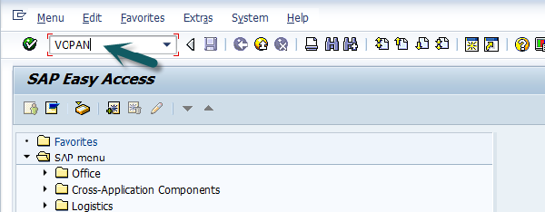

A new window will open. Select the Partner Object and click the Change button.

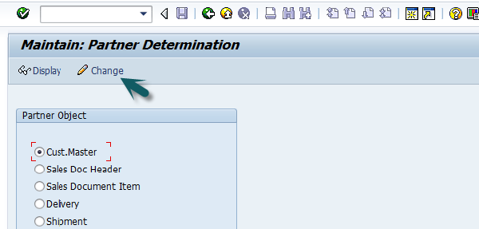

It will open a new window with the name Partner Determination Procedures. Go to New Entries.

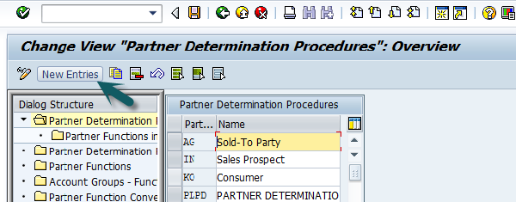

Enter the name and partner determination procedure and double click on Partner Function in left pane.

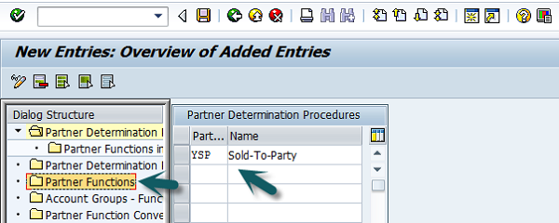

Click the New Entries button.

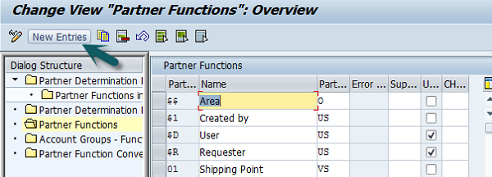

Enter the Partner function details − Name, Type, etc. KU- stands for Customer.

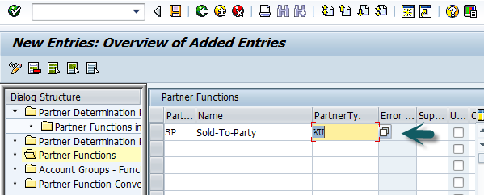

Next is to click on the Partner Function under Partner Determination Procedure node and enter the details Partner Det. Procedure, Name, Partner Function.

Then, we need to assign this partner determination procedure to the Partner Object. The Partner Object would be a Customer for this example. Then Click on Account Groups and Select the Account group name from the list. Once it is done, Click **Save**, it will save the partner function.

SAP SD - Create Material Stock

Suppose you have implemented SAP in your company and now you want to put all your stocks in the SD system. For this, **use T-Code: MB1C Movement Type: 561** this is for Good receipts without reference.

**Movement Type: 501** − this is used for receiving goods with a Purchase Order.

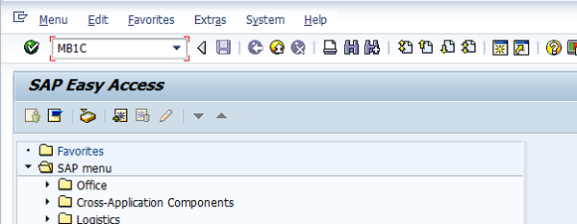

A new window will open. Enter the document date, Plant and storage location, Movement type, etc.

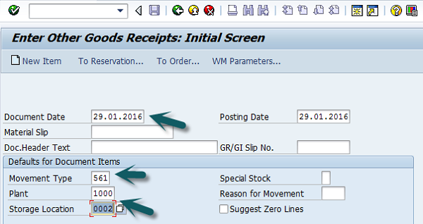

Select the Movement type from the list and Press Enter after selecting all the details.

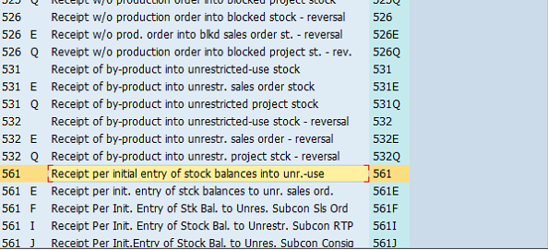

A new window will open. Enter the material code and quantity for which stock needs to be created and then click Save.

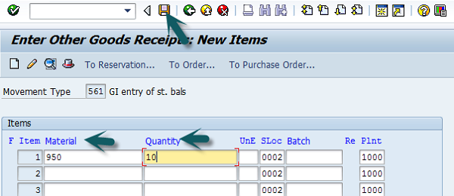

A message Document 300045646 posted will be displayed.

SAP SD - Create MM for Sales View

A Material Master is created in SAP SD system by the material department. Once it is created, the person who manages sales related material has to extend sales views.

Use **T-Code: MM01** to create material master for different views. To check the changes, use **T-Code: MM04**

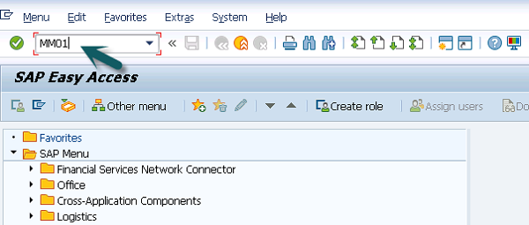

A new window will open. Enter the Industry Sector and Material Type. Click Select View(s).

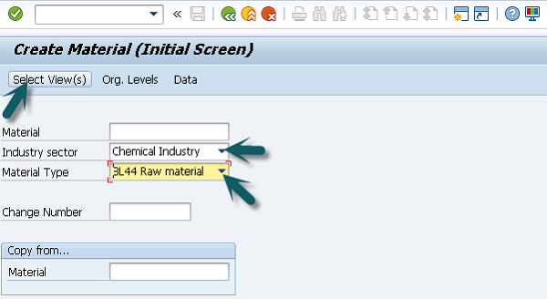

Select Sales Org Data 1, Sales Org Data 2, Sales: General/Plant Data and click the Green tick mark below.

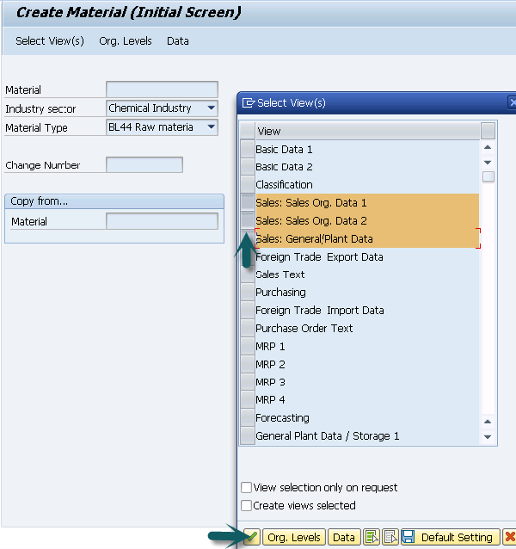

Then a new window will open. Enter the Plant, Sales Organization and Distribution Channel for which the material is to be extended. Repeated entries have to be made for various materials with the above selections.

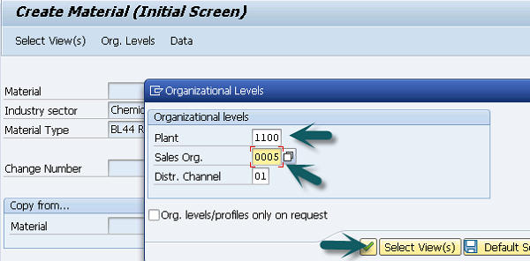

A new window will open, then you can enter the following details −

* Material Details
* Base unit of Measure
* Division
* Material Group
* Tax

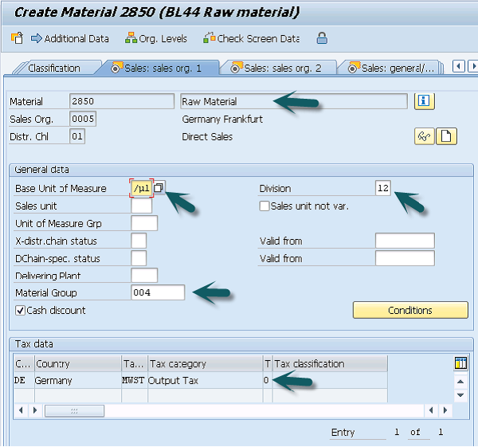

Then, go to Sales Org 2 tab. This information is required for analysis.

* **Material Statistics Group** − Value should be ‘1’ always. Value in this field with Customer Statistical Group maintained in customer master will update the information system.
* **Gen Item Category Group and Item Category Group** − Generally for Finished Products value NORM will default in both the fields.

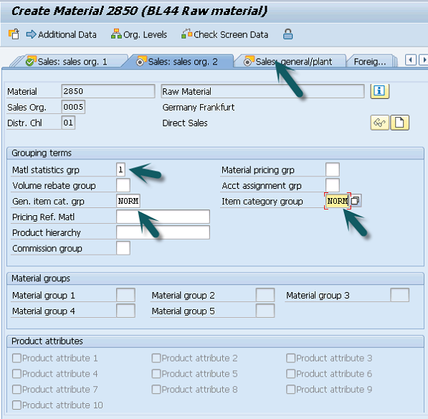

**Go to Sales** − General/Plant tab. Enter the value of Availability check, Transport group and loading group, SerialNoProfile (managed if base unit of measure is discrete, not required here) and Press Enter → Yes

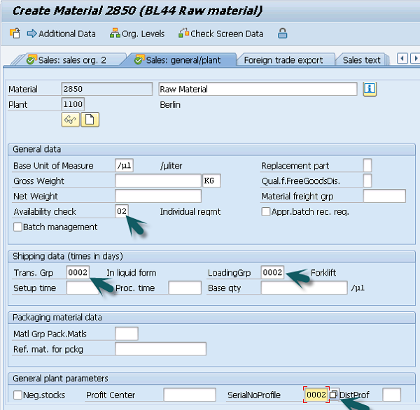

You will get a confirmation message.

Confirmation Message

SAP SD - Pre-Sales Activities

All Sales activities in this SAP SD system can be divided into presales and post sales activities. **Pre-sales activities** are classified as activities that take place before a product is sold to the customer. In contrast, **post-sales activities** are those that take place after a product is sold.

There are two types of pre-sales activities in Sales and Distribution −

Inquiries

Inquiries are the inquiries received from customers like, if a product is available, costing of product, delivery of a product, etc.

Different T-Codes

* **VA11** − Create Inquiry Logistics → Sales and Distribution → Sales → Inquiry → Create.
* **VA12** − Change Inquiry
* **VA13** − Display/Search Inquiry

Quotation

A quotation is a legal document to the customer for delivery of goods and services.

Different T-Codes

* **VA21** − Create Quotation
* **VA22** − Change Quotation
* **VA23** − Display/Search Quotation

In this chapter, we will see how to create inquiries in SAP SD.

Create Inquiries

An Inquiry is not a legal document and is used to record the information about delivery or services from customers. The information that is captured using an inquiry is related to materials and quality of goods.

Menu Path: Logistics → Sales and Distribution → Sales → Inquiry → Create T-Code: VA11

When you run this T-code, you need to fill the below information to create an inquiry.

|  |  |
| --- | --- |
| **Field** | **Data** |
| Inquiry type | ZEC 1 (IECPP inquiry) |
| Sales organization | 4000 |
| Distribution channel | 40 |
| Division | 00 |

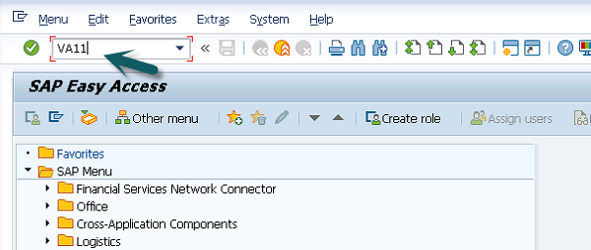

Enter Inquiry Type as IN and Organizational Data as below and then click Sales.

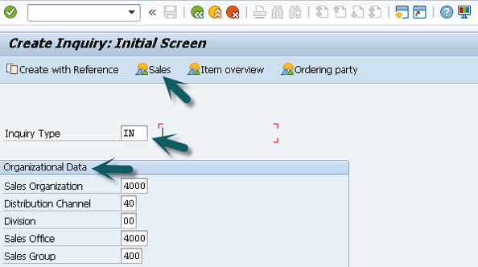

The Sales Office is an optional entry, which helps in reporting. Then a new window will open. Enter Partner Function (Sold-To-Party/Ship-To-Party). Enter the material code and quantity and then Click Save.

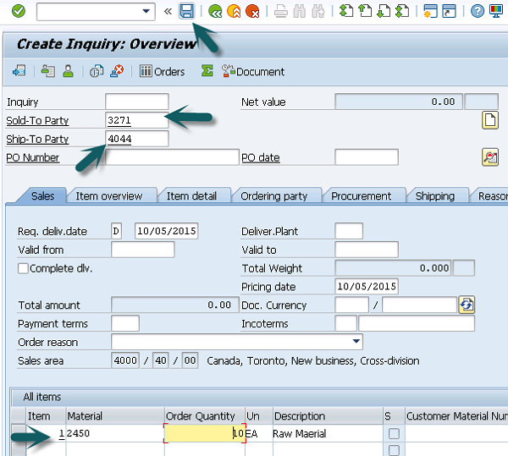

A Message – Inquiry 10000037 has been saved will be displayed.

SAP SD - Create Quotations

A **quotation** is a legal document to the customer for delivery of goods and services. This is normally issued after an inquiry from the customer or without an inquiry.

**SAP R/3 Menu** − Logistics → Sales and Distribution → Sales → Quotation → Create **T-Code: VA21**

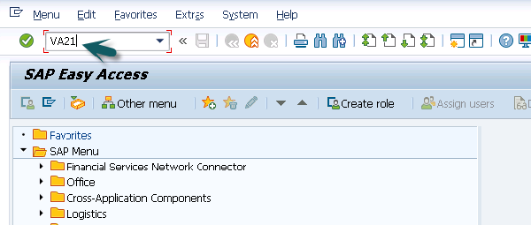

Enter the Quotation Type, then you can enter the Sales Organization, Distribution Channel, Division and then click Create with Reference.

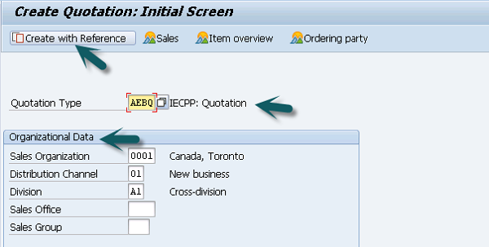

A new window will open, then enter the Inquiry number and click Copy. It will fetch all the details from that Inquiry document.

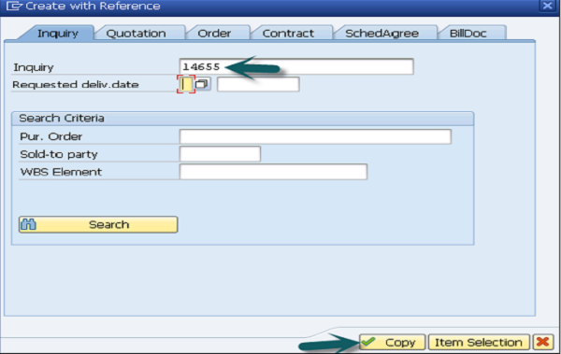

Then another new window will open. Enter the following details −

* Enter Partner Function, Sold-To-Party, Ship-To-Party
* Enter Purchase Order #
* Enter Valid from and Valid to Date
* Enter Quantity of material

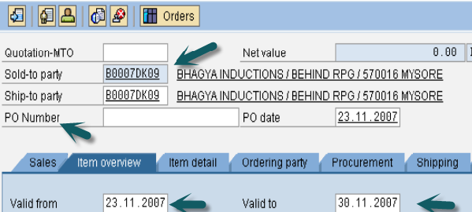

After this, click save. A Message will be displayed Quotation 40000047 has been saved.